Architectural Patterns
# Source: AI Source: Provided by: [Data Path: Persons Table -> ID Column: 1, Name_En Column: Motasem Essam] -> From: [ChatGPT] on [1/23/2026]
Architectural patterns are proven, reusable solutions to common design problems in software architecture. They provide guidance on how to organize components and their interactions to solve a recurring problem, but they are more specific than architectural styles.

Key Points About Architectural Patterns:
# Source: AI Source: Provided by: [Data Path: Persons Table -> ID Column: 1, Name_En Column: Motasem Essam] -> From: [ChatGPT] on [1/23/2026]
- Problem-Solution Approach:
  - Patterns describe a recurring problem in software architecture and provide a template solution.
  - They are practical and implementable, unlike styles, which are abstract.
- Guidelines, Not Complete Code:
  - Patterns suggest how components communicate, how responsibilities are distributed, and how data flows, but they don’t provide full implementation.
- Often Associated With Styles:
  - Patterns are usually applied within an architectural style.
  - Example: MVC pattern is often used in a layered style web application.

Common Architectural Patterns:
# Source: AI Source: Provided by: [Data Path: Persons Table -> ID Column: 1, Name_En Column: Motasem Essam] -> From: [ChatGPT] on [1/23/2026]
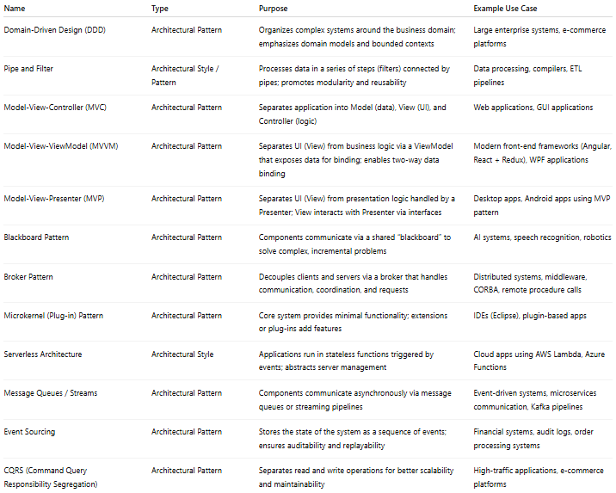
Name | Type | Purpose | Example Use Case
Domain-Driven Design (DDD) | Architectural Pattern | Organizes complex systems around the business domain; emphasizes domain models and bounded contexts | Large enterprise systems, e-commerce platforms
Pipe and Filter | Architectural Style / Pattern | Processes data in a series of steps (filters) connected by pipes; promotes modularity and reusability | Data processing, compilers, ETL pipelines
Model-View-Controller (MVC) | Architectural Pattern | Separates application into Model (data), View (UI), and Controller (logic) | Web applications, GUI applications
Model-View-ViewModel (MVVM) | Architectural Pattern | Separates UI (View) from business logic via a ViewModel that exposes data for binding; enables two-way data binding | Modern front-end frameworks (Angular, React + Redux), WPF applications
Model-View-Presenter (MVP) | Architectural Pattern | Separates UI (View) from presentation logic handled by a Presenter; View interacts with Presenter via interfaces | Desktop apps, Android apps using MVP pattern
Blackboard Pattern | Architectural Pattern | Components communicate via a shared “blackboard” to solve complex, incremental problems | AI systems, speech recognition, robotics
Broker Pattern | Architectural Pattern | Decouples clients and servers via a broker that handles communication, coordination, and requests | Distributed systems, middleware, CORBA, remote procedure calls
Microkernel (Plug-in) Pattern | Architectural Pattern | Core system provides minimal functionality; extensions or plug-ins add features | IDEs (Eclipse), plugin-based apps
Serverless Architecture | Architectural Style | Applications run in stateless functions triggered by events; abstracts server management | Cloud apps using AWS Lambda, Azure Functions
Message Queues / Streams | Architectural Pattern | Components communicate asynchronously via message queues or streaming pipelines | Event-driven systems, microservices communication, Kafka pipelines
Event Sourcing | Architectural Pattern | Stores the state of the system as a sequence of events; ensures auditability and replayability | Financial systems, audit logs, order processing systems
CQRS (Command Query Responsibility Segregation) | Architectural Pattern | Separates read and write operations for better scalability and maintainability | High-traffic applications, e-commerce platforms

Analogy:
# Source: AI Source: Provided by: [Data Path: Persons Table -> ID Column: 1, Name_En Column: Motasem Essam] -> From: [ChatGPT] on [1/23/2026]
- Architectural style = city layout (roads, districts)
- Architectural pattern = design of a specific building or solution in that city

In short:
# Source: AI Source: Provided by: [Data Path: Persons Table -> ID Column: 1, Name_En Column: Motasem Essam] -> From: [ChatGPT] on [1/23/2026]
- Style = “overall organization”
- Pattern = “reusable solution within that organization”

